Course Description

Topic | Research Misconduct and Academic Writing Skills
Duration | 3 hours
Participants | Undergraduate and graduate students
Objectives | The purpose of this course is to introduce participants three basic academic writing skills, namely paraphrasing, summarizing and quoting, and five common types of research misconduct (e.g., plagiarism). When participants complete the course, they should be able to:  - understand the definition and types of research misconduct;  - understand the types of research misconduct that should be avoided when conducting research; and  - understand the usage of the three academic writing skills: paraphrasing, summarizing, and quoting.
Suggested Method | Lecture, instructor-student discussion, and paired discussion
Structure | 1. The Definition of Misconduct  2. Types of Research Misconduct  2.1. Inappropriate Data Collection  2.2. Data Fabrication and Falsification  2.3. Plagiarism  2.3.1. The Writing Skill of Paraphrasing  2.3.2. The Writing Skill of Summarizing  2.3.3. The Writing Skill of Quoting  2.4. Inappropriate Authorship  2.4.1. Inappropriate Authorship and Designation  2.5. Duplicate Submission and Publication  3. Conclusion
Course Materials | - PowerPoint slide presentations (98 pages in total)  - Teacher’s guide  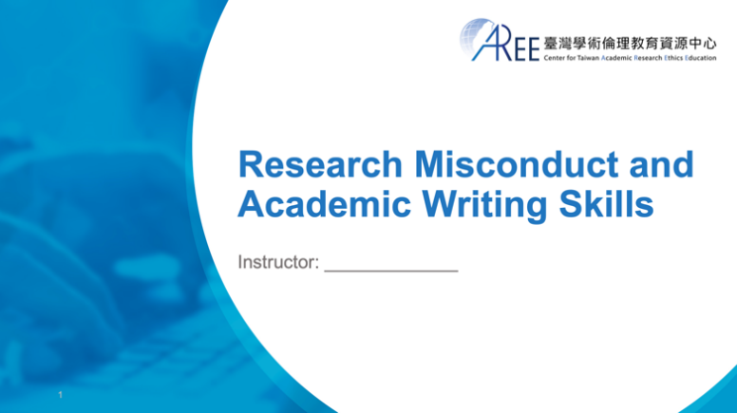  - Quiz sheet

List of Questions for Discussion
The questions have been included in the PowerPoint slides as Think About It.
After you have lectured the PowerPoint (PPT) slides, use these or similar questions to generate discussion, enhance comprehension, and develop appreciation for the content. You may encourage participants to refer to passages and/or illustrations in the slides to support their responses.
Q1. Open Discussion (also see p. 14 in the PPT slides)
- Without the consent of the author, Guang duplicated parts of data and content from that article and pasted to his own report. Is this appropriate?
- If not, what should Guang have done?
Q2. Open Discussion (also see p. 15)
- Is it right that Joe ignored the malfunction message of his equipment, continued his experiment, and used the inaccurate data in his research report?
- If not, what should he have done?
Q3. Open Discussion (also see p. 23)
- Is it appropriate that Shin falsified research data only because the original data did not fit the research hypothesis?
- If Shin had decided not to falsify the data, what else could he have done to meet his advisor’s expectations?
Q4. Open Discussion (also see p. 24)
- Is it appropriate that Flora used a photo of irrelevant objects as a photo of the research results?
- Would there have been any other way to finish the observation report before the deadline?
Q5. Open Discussion (also see p. 29)
- Is it appropriate that Guang copied the Web articles and used them in his report?
- Is there another way to cite others’ articles rather than simply copying-and-pasting?
Q6-1. Yes-No Question & Open Discussion (also see p. 32)
Joe was very interested in a research article published in 1990, and he wanted to use the same research methods to conduct his own research so he could compare the differences.
Joe: “I only have to cite the article published in 1990 and state my research objectives. Follow the same procedure again and compare the two research results.”
Is Joe’s decision and action appropriate?
Q6-2. Yes-No Question & Open Discussion (also see p. 33)
Guang was analyzing data, and he needed data from the five-year-old national population to compare with his own. Guang followed Flora’s advice and retrieved the information he needed from the website of the Department of Statistics of the Ministry of Education.
Guang: “These charts were made by the government for public use. So, I can simply copy the charts and use them in my research paper for further analysis.”
Is Guang’s decision and action appropriate?
Q6-3. Yes-No Question & Open Discussion (also see p. 34)
Shelly could not come up with a topic for her thesis. Following Cindy’s suggestion, she went to the library to look at predecessors’ works for inspiration, and she found one particular thesis from abroad that matched her interest.
Shelly: “I plan to translate a thesis into Chinese, adopt the research ideas and research procedure described in this thesis, and directly use the data of in my thesis since when I don't have sufficient data so far. What a brilliant idea.”
Is Shelly’s decision and action appropriate?
Q7. Open Discussion (also see p. 68-70)
- Shin is a graduate student at an information research institute. While writing his thesis, Shin met many individuals who offered him a lot of assistance and valuable advice. Who can be listed as co-authors?

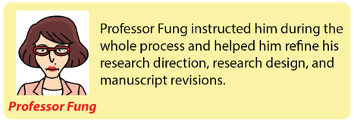
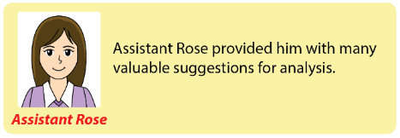
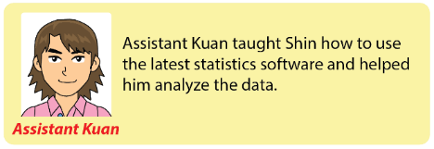
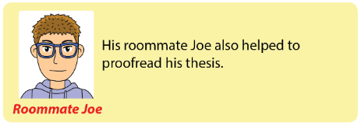
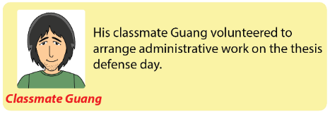
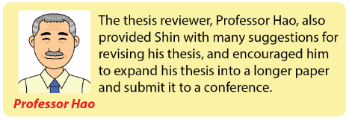

(continued)
After revising the thesis manuscript, Shin talked to Professor Fung about submitting a paper to a conference. They decided to use some of the data in the thesis to conduct further statistical analysis, and they put all of the results together, turning them into a paper and submitting it to a conference in the field of information technology. With so much assistance from others throughout the process, Shin wondered who qualified as an author of the submitted paper and who should be included in the acknowledgments section.
- If you were Shin, who would you list as a co-author of the conference paper?
- And who should be mentioned in the acknowledgments section?

Answer Key
The PowerPoint slides do not include the answer keys.
Q1. Open Discussion (also see p. 14)
This is inappropriate. What Guang did could constitute “inappropriate data collection” and “plagiarism,” both violating research ethics. The appropriate approach is that after understanding the key points in that researcher's paper, Guang should use his own words to paraphrase or summarize the content and accurately cite the source. If necessary and within reasonable limits, he can use quotation marks to quote certain sentences but must also accurately cite the source.
Q2. Open Discussion (also see p. 15)
It is inappropriate. What Joe did could constitute “inappropriate data collection,” which is a violation of research ethics. Joe should have recalibrated the equipment and conducted the experiment again.
Q3. Open Discussion (also see p. 23)
What Shin did could be seen as “data falsification,” which is a type of research misconduct and a violation of research ethics. In fact, results that do not fit the hypothesis also have value. Shin should have been honest and reported the data to his advisor, discussing why the results did not fit the hypothesis. If the error relates to research design or execution, then the experiment should be conducted again; if not, the results that are inconsistent with the theory may be treated as a research result and the researcher can attempt to explain it.
Q4. Open Discussion (also see p. 24)
It is inappropriate. What Flora did could be seen as “data fabrication” and a violation of research ethics. Flora should record her observations faithfully and should not fabricate research data, even if she could not finish her report before the deadline.
Q5. Open Discussion (also see p. 29)
It is inappropriate. What Guang did could be seen as “plagiarism,” which is a violation of research ethics. In addition, his behavior could have infringed the author's copyright and violated the Copyright Act. He should first understand others’ articles, use his own words to paraphrase or summarize the content, and give credit to the author and the source material.
Q6-1. Yes-No Question & Open Discussion (also see p. 32)
The answer is “Yes.”
Q6-2. Yes-No Question & Open Discussion (also see p. 33)
The answer is “No.”
Q6-3. Yes-No Question & Open Discussion (also see p. 34)
The answer is “No.”
Q7. Open Discussion (also see p. 68-70)
Both Shin and his advisor, Professor Fung, have made substantial contributions to the thesis and conference paper, so they qualify to be listed as the authors of the paper. However, other people, such as assistant Rose, assistant Kuan, Joe, Guang, and Professor Hao, made only a single, insubstantial contribution to the paper (making suggestions, instructing Shin on how to use statistical software, proofreading the thesis, and running errands on the defense day). As a result, they cannot be listed as authors, but Shin can acknowledge their assistance and support to express his appreciation.

Quiz
The quizzes have been included in the PowerPoint slides and Quiz Sheet.
After you have lectured all the PowerPoint slides, use these quizzes (multiple-choice questions) to evaluate participants’ learning outcomes.
Q1. Which of the following writing skills is incorrect while paraphrasing?
- Paraphrasing is employed when reproducing the meaning or connotation of a paper or integrating the meaning of multiple papers into one paragraph.
- Retain the author’s viewpoint from the original text and incorporate the researcher’s own perspective accordingly to extend the original idea.
- The length of the paraphrased text is completely different from the length of the original text.
- It is an “in other words” type of concept that utilizes other words and descriptions to convey the essence of the original text.
Q2. Which of the following writing skills is incorrect while summarizing?
- Summarizing is employed when reducing a lengthy fragment of text such as one complete section or the entire book.
- The summarized text is longer than the original one and more sentences are added to interpret the original text.
- The summarized text is shorter than the original.
- It is an “in a nutshell” type of concept that uses fewer words to convey most of the content in the original text.
Q3. Guang has several projects due by the end of the semester. To ensure these projects are completed before their due dates, Guang asks his senior fellow students for their past projects for reference. However, Guang is running out of time to paraphrase those projects appropriately and instead, incorporates everything into his own report verbatim. Finally, Guang is able to finish all his projects on time. What type of research misconduct does Guang’s behavior commit?
- Inappropriate data collection
- Data fabrication/falsification
- Plagiarism
- Duplicate submission/publication/application
Q4. The graduate institution where Guang studied required all graduate students to publish at least one journal paper before graduation. However, Guang was too busy writing his thesis, so he did not have time to draft another manuscript for journal publication. As a result, he went to an online platform that graduate students often visit, seeking help in hopes of finding another graduate student who would be willing to list them as the second author of that graduate student’s journal paper. In this situation, what type of research misconduct did Guang commit?
- Inappropriate data collection
- Data fabrication/falsification
- In appropriate authorship/designation
- Duplicate submission/publication/application
Q5. The graduate institution where Guang studied required all graduate students to publish at least one journal paper before graduation. After composing a manuscript for journal submission, Guang found that the graduation deadline was approaching, and he was not sure whether his paper would be accepted before the deadline. As a result, he submitted the same manuscript to three different journals to increase the likelihood of acceptance. He also decided that, once the paper was accepted to any one of the journals, he would withdraw the other two submissions. In this situation, did Guang commit research misconduct?
- No, because he would only publish in one journal in the end.
- No, because what Guang did only increases the acceptance rate of his paper, which is quite common in the academic field.
- Yes. To avoid research misconduct, Guang should simply accept the multiple publication.
- Yes. Although Guang would only choose one journal to publish his paper, submitting the same paper to different journals constitutes duplicate submission, which is a violation of research ethics.

Answer Key
The PowerPoint slides and Quiz Sheet do not include the answer keys.
Q1.
Item (c) is the correct answer. The length of the paraphrased text should be approximately the same as the original.
Q2.
Item (b) is the correct answer. The length of the summarized text should be shorter than the original.
Q3.
Item (c) is the correct answer. It is considered plagiarism that Guang incorporated the entire content from the senior student’s projects verbatim. In addition to violating research ethics, Guang has also violated the right to reproduce in the copyright law. If Guang’s paper is published, he may also violate the right of public transmission in the copyright law.
Q4.
Item (c) is the correct answer. Guang did not write the journal paper, and he asked for authorship of others' papers. This behavior could be seen as inappropriate author assignment and a violation of research ethics.
Q5.
Item (d) is the correct answer. Journals usually ask authors to sign a self-reported statement to avoid possible duplicate submission. The purpose of the statement is to ensure effective usage of academic resources and to avoid copyright controversies. In this case, one can see that Guang’s behavior is a violation of research ethics because he submitted the same manuscript to multiple journals. The ideal approach is to submit the manuscript to only one journal at a time. Guang could only submit the manuscript again to other journals once it was rejected by the previous journal.

Additional Quiz and Answer Key
The quizzes have not been included in the PowerPoint slides and Quiz Sheet.
You may add these quizzes to Quiz Sheet if needed.
Q1. Which of the following academic research behaviors may constitute “plagiarism”?
  - The entire portion was copied from the work of others without indicating the source.
  - The statistical results of one’s research data were not satisfactory, so the data was manipulated to meet the expected results.
  - The works of others were reorganized without citing the source to make it looks like it was the researcher’s own work.
  - Different passages of different articles were copied separately, and the sources were not clearly cited.
- AC
- ACD
- ABC
- ABCD
Answer Key: Item (b) is the correct answer. The statistical results of one’s research data were not satisfactory, so the data was manipulated to meet the expected results” is a case of “data falsification.
Q2. Which of the following is not a consequence of plagiarism?
- Possible damage to one’s academic reputation.
- The degree may be revoked.
- The original author may appreciate your effort to copy his/her work.
- The original author may file a lawsuit.
Answer Key: Item (c) is the correct answer.
Q3. Which of the following principles can help researchers avoid improper data processing?
- Record all the experiment data and confirm the correctness of the data.
- Do not fabricate or falsify research data or results because they did not meet expectations.
- Consult experts or professors if there are questions about the processing of research data.
- All of the above.
Answer Key: Item (d) is the correct answer. All the three actions mentioned in the items can help to ensure the accuracy of the research and prevent the improper processing of data.
Q4. Which of the following are incorrect descriptions of falsification?
- Refers to the researcher changing or deleting research data, results, or images.
- Refers to the researcher manipulating research materials or equipment to verify their own set of research hypotheses.
- In order to support the hypothesis of research, the researcher adjusted values that failed to reach a level of statistical significance so as to reach the level of statistical significance. This behavior is called “falsification.”
- The deadline of the seminar is approaching but the data just received would not have enough time to undergo statistical analysis. Therefore, some values should be entered and analyzed at random to complete the paper quickly. This behavior is called “falsification.”
Answer Key: Item (d) is the correct answer. The creation of nonexistent data to quickly complete a paper is a form of data fabrication.
Q5. Which of the following scenarios in academic writing require(s) the use of quoting?
- Citing someone else’s argument
- Reporting the original response of an interviewee
- Citing a secondary source
- All of the above
Answer Key: Item (d) is the correct answer.
*** You may visit https://ethics.moe.edu.tw/resource/ for more educational materials. ***

This license allows users to distribute, remix, adapt, and build upon the material in any medium or format for noncommercial purposes, and only so long as attribution is given to the Center for Taiwan Academic Research Ethics Education. (The material is created on September 2, 2021.)

